THE GREAT CHEESE HUNT

A NEW MICROMOUSE EVENT

TECHNICAL BULLETIN #1

PUBLICATION RIGHTS RESERVED

ADDRESS QUESTIONS TO:

DR. ANDREW R. SASS

IEEE, L.I. SECTION

arshacker@aol.com

TABLE OF CONTENTS

PG.

INTRODUCTION 3

COMPETITION DESCRIPTION 3

TECHNICAL DETAILS 7

USING THE ARDUINO NANO 14

USING AN ARDUINO OTHER THAN

THE NANO 20

BUILD A PRACTICE BEACON 22

BUILD A “SKELETON” MOUSE 24

APPENDIX 1-SCOPE PICTURES 28

APPENDIX 2-HOW TO USE THE

MOUSE CODE 33

INTRODUCTION

This bulletin is a technical description of a new Micromouse event that does not replace traditional Micromouse but is another event which will run in addition to it.

COMPETITION DESCRIPTION

As contrasted to Traditional Micromouse, in “Micromouse: The Great Cheese Hunt”, the position of the Goal is unknown. The Goal can be in any place in the Maze. The position of the Start is in one corner, as usual.

Since the position of the Goal is unknown, different search strategy/algorithms from Traditional Micromouse will be required since in Traditional Micromouse, the Goal is always at the Center of the Maze.

The Goal is a low-power 940 nm, 40 kHz, pulsed, IR Beacon which can be sensed by a Mouse with an IR Sensor with a built-in band-pass filter. When the Mouse detects and extinguishes the Beacon, it is required by the rules of the Competition to put out the Beacon and return to Start.

There are 2 options for the Mouse to put out the Beacon.

Option 1. The mouse generates its own IR signal with an on-board IR LED which triggers an IR sensor attached to the Beacon.

Option 2. The Mouse triggers a proximity sensor attached to the Beacon by coming to within 1 cm of the sensor which is connected to the Beacon.

A team can pick either option,

PROGRAMS FOR THE BEACON AND EACH MOUSE OPTION ARE GIVEN IN THIS REPOSITORY.

TRYING EACH OPTION, TO DECIDE WHICH PROGRAM IS EASIER TO OPERATE IN COMPETITION, IS RECOMMENDED !

The Mouse which finds the Goal, extinguishes it, and returns to Start in the shortest time, WINS. Next shortest time, 2nd place, and so on.

The Maze will be an 8 X 8 whose internal dimensions are identical to the usual 16 X 16 Maze used for Traditional Micromouse.

TECH DETAILS OF THE IR BEACON, HARDWARE AND CODE, ARE PROVIDED IN THE NEXT SECTION AND THE APPENDICIES SO TEAMS CAN BUILD A PRACTICE BEACON.

BUILDING A PRACTICE BEACON IS HIGHLY RECOMMENDED!!!

SIMILARLY TECH DETAILS SHOWING A “SKELETON” MOUSE, HARDWARE AND CODE SNIPPETS, WHICH CAN EXECUTE OPTIONS 1 AND 2 ARE ALSO GIVEN TO ASSIST TEAMS IN ADDING IR CAPABILITY TO THEIR “MICE”.

ADDING IR CAPABILITY TO A MOUSE REQUIRES ONLY A FEW VERY LOW COST COMPONENTS WITH A BILL Of MATERIALS OF ONLY A FEW DOLLARS. SIMILARLY, A PRACTICE BEACON CONSISTING OF A FEW COMPONENTS, COSTING ONLY A FEW DOLLARS, IS EASILY BUILT.

DURING THE DEVELOPMENT OF THIS PROJECT, IT IS HIGHLY RECOMMENDED THAT AN OSCILLOSCOPE, TO MONITOR SIGNALS TO THE IR LED AND FROM THE IR SENSOR, BE USED. A SIMPLE 2-PROBE SCOPE WILL BE HELPFUL, ESPECIALLY AT THE BEGINNING OF THE PROJECT.

TECHNICAL DETAILS

THE IR BEACON

The IR BEACON is an Arduino Nano as shown in the left side of the diagram in Fig. 1.

FIG. 1.

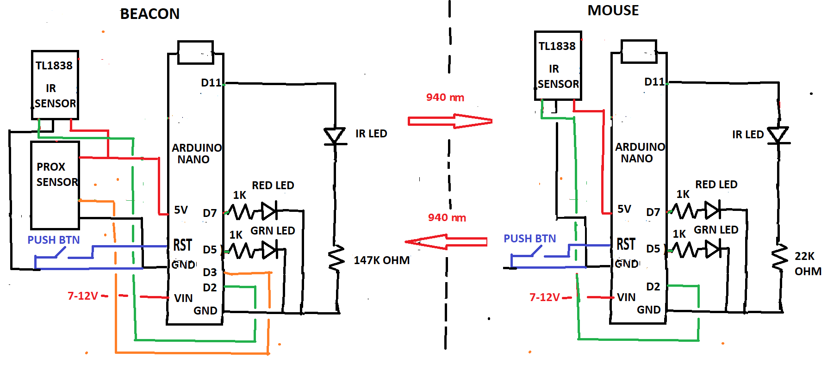

The Beacon Nano is programmed to produce a low power pulse modulated 40 kHz signal which drives a 940 nm IR LED. The range of the Beacon signal is about 9 cm as set by the 147K resistor. The range is not a sharp dropoff-gradual decrease in sensor effectiveness from 9 cm to about 18 cm- as described in Build a Skeleton Mouse section below).

The IR LED signal is pictured in Fig. 2. Also pictured in Fig. 2 is the output sensor signal of the detector.

Fig. 2.

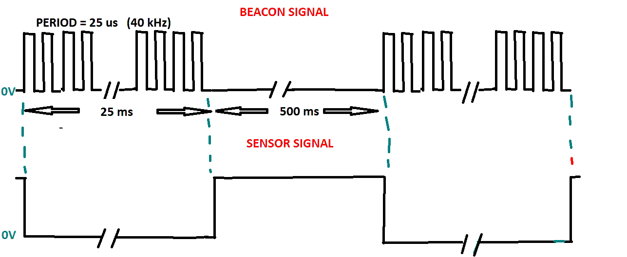

It is important to note that the sensor signal is a pulse which goes from a high voltage (approx. 5V) to 0V when the Beacon signal is detected. The IR LED and the TL 1838 are part of the package shown below.

Scope pictures of the BEACON and SENSOR signals are given in Appendix 1 of this document.

BILL OF MATERIALS: BEACON

This link describes a package of 10 IR LED emitters, 5 ordinary IR sensors, and 5 TL 1838 sensors with the package costing less than $6.00.

<https://www.amazon.com/dp/B07TLBJR5J?ref=ppx_pop_mob_ap_share>

In the above picture, the IR LED with 2 wires is clear, the standard IR Sensor(not used in this project) with 2 wires is black, and the TL 1838 IR Sensor(which is used in this project) has 3 wires with an X on the Black face and is in the metal can.

The pin diagram for the TL 1838 is shown in Fig. 3 below.

FIG. 3

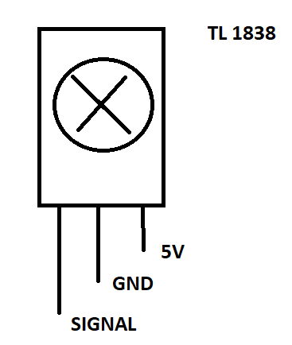

The physical size of the TL 1828 is about the size of 7.3 mm X 7.3 mm X 5.4 mm.

The TL 1838 has a 38 kHz bandpass filter. The bandpass is wide enough to pass our 40 kHz signal. Its datasheet link is here.

[VS1838-Infrared-Receiver-datasheet.pdf](https://eeshop.unl.edu/pdf/VS1838-Infrared-Receiver-datasheet.pdf)

THE IR LED BEAM ANGLE AND RECEIVER SENSITIVITY ANGLE OF THE SENSOR ARE SHOWN IN FIG. 4.

FIG. 4

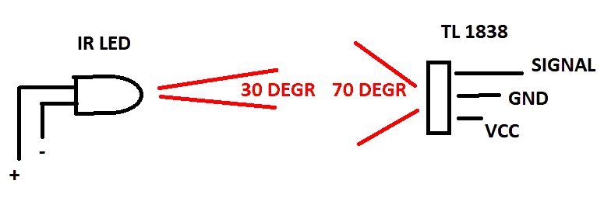

The Proximity Sensor in the Beacon, used for OPTION 2 and shown in the Beacon section in Fig. 1 can be obtained using the link below.

PROXIMITY SENSOR $8.- PACK OF 3.

<https://www.amazon.com/dp/B07S6BDMP9?ref=cm_sw_r_apan_dp_01P0WR0VXC5ZYJ0YA8FH&ref_=cm_sw_r_apan_dp_01P0WR0VXC5ZYJ0YA8FH&social_share=cm_sw_r_apan_dp_01P0WR0VXC5ZYJ0YA8FH&starsLeft=1&skipTwisterOG=1>

ARDUINO NANO-PACK OF 3-$20.

<https://www.amazon.com/dp/B07G99NNXL?ref=cm_sw_r_apan_dp_PP17AT5X47MWDYMVF3AD&ref_=cm_sw_r_apan_dp_PP17AT5X47MWDYMVF3AD&social_share=cm_sw_r_apan_dp_PP17AT5X47MWDYMVF3AD&starsLeft=1&skipTwisterOG=1>

Using the Arduino Nano

If you are already using a Nano for other purposes, you can ignore this section.

NOTE THAT USB SERIAL CH340 DRIVER

MUST BE INSTALLED ON YOUR COMPUTER

AS SHOWN BY THE DEVICE MANAGER, PORT SECTION PICTURE BELOW. IN THE PICTURE, THE BEACON NANO AND MOUSE NANO ARE CONNECTED TO COM 10 AND 11 RESPECTIVELY.

A LINK EXPLAINING THE INSTALLATION OF THE DRIVER IS

[How to Install CH340 Drivers - SparkFun Learn](https://learn.sparkfun.com/tutorials/how-to-install-ch340-drivers/all)

A LINK FOR THE DRIVER ITSELF IS

<https://www.arduined.eu/ch340-windows-10-driver-download/>

HERE IS THE BEACON NANO AND MOUSE NANO AS SEEN BY MY WINDOWS MACHINE

DEVICE MANAGER IN THE PORTS SECTION.

COM INFO IS USED TO DOUBLE CHECK THE COM INFO IN THE IDE TOOLS SECTION.

MINICORE:

TO DOWNLOAD TO THE NANO BOARD, INSTALL THE MINICORE IN ARDUINO IDE. HERE IS THE LINK FOR EXTENSIVE INFO.

[MiniCore/README.md at master · MCUdude/MiniCore · GitHub](https://github.com/MCUdude/MiniCore/blob/master/README.md#boards-manager-installation)

Here is the specific info from the link

**Boards Manager Installation**

This installation method requires Arduino IDE version 1.8.0 or greater.

* Open the Arduino IDE.
* Open the **File > Preferences** menu item.
* Enter the following URL in **Additional Boards Manager URLs**:
* https://mcudude.github.io/MiniCore/package_MCUdude_MiniCore_index.json
* Open the **Tools > Board > Boards Manager...** menu item.
* Wait for the platform indexes to finish downloading.
* Scroll down until you see the **MiniCore** entry and click on it.
* Click **Install**.
* After installation is complete close the **Boards Manager** window.

Here is the recommended configuration in the TOOLS section of the IDE

TOOLS

BOARD MANAGER-ATMEGA 328

BOOTLOADER-YES UART0

CLOCK-EXTERNAL 16 MHZ

COMPILER LTO-LTO ENABLED

EEPROM-EEPROM RETAINED

VARIANT-328P/328A

BOD-BOD 2.7V

SCREENSHOT OF TOOLS/

BOARD Atmega 328

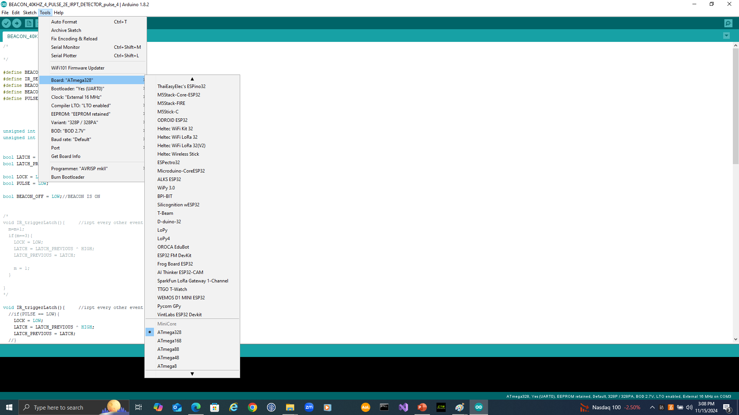

USING AN ARDUINO OTHER THAN THE NANO

As will be seen in the codes in the next 2 sections on Building a Practice Beacon and Building a “Skeleton”Mouse, there are a few Assembler instructions(including one in each Setup). These are Port instructions dependent on the Port assignments for the particular Arduino under consideration.

Here are Port assignments for the Arduino NANO, UNO, and MEGA. A team can use an UNO or MEGA (or even another NANO pin).

NANO

PORT B

5 D13

1. D12
2. D11
3. D10
4. D9

0 D8

PORT D

0 TX

1 RX

1. D2
2. D3
3. D4
4. D5
5. D6
6. D7

PORT C

0 A0

1 A1

2 A2

1. A3
2. A4
3. A5

UNO

PORT D 0-7

PORT B 8-13

MEGA

PORT A 22-29

PORT K A8-A15

PORT F A0-A7

PORT C 37-30

PORT G 41-39(0-2), 4(5)

PORT B 53-50 AND 10-13

PORT H 21-17

PORT L 49-42

PORT J 15-14

BUILD A PRACTICE BEACON (IDENTICAL TO THE COMPETITION BEACON):

Construct a Practice Beacon as per Fig. 1 above with both the IR sensor and Proximity Sensor so that you can try OPTION 1 and OPTION 2.

POINT THE BEACON IR LED AS SHOWN HERE.

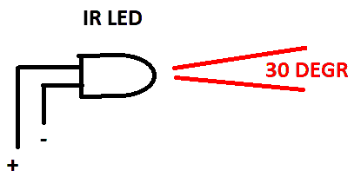

The Beacon Code is given in this REPOSITORY and is relatively straightforward and easy to follow. It can be downloaded and run.

The code consists of the 40 kHz pulse generator (25 ms ON, 500ms OFF), an interrupt for the proximity sensor on Pin 3 triggered on the rising edge, an interrupt for the IR sensor on Pin 2 triggered on the falling edge, and 2 LEDs to signal when the Beacon is ON (RED) and OFF (GREEN).

POINT THE IR SENSOR AS SHOWN HERE

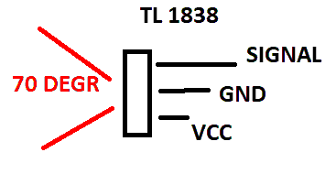

Each interrupt independently disables (shuts-off) the 40 kHz signal which marks the fact that the Beacon has been found and turned-off.

As explained earlier, the Mouse can use either the proximity sensor or IR sensor to turn off the Beacon. When the Beacon is off, its Green LED is turned on and its Red LED is turned off.

Once the Beacon is built and powered, the Pin 11 40 kHz pulsed voltage on the IR LED can be viewed with an oscilloscope and the RED LED is ON and the GREEN LED is OFF.

When the Proximity Sensor is triggered by an object less than 1 cm away, or the IR SENSOR triggered from the Mouse (OPTION 2) described in the next section, the Pin 11 voltage is set to 0 by the program and the GREEN LED is ON and the RED LED is OFF.

The Judges will use the RED and GREEN LEDs to see when the Mouse has extinguished the BEACON.

BUILD A “SKELETON” MOUSE

THE MOUSE

The Mouse shown in Fig. 1 is based on Option 1 where the Mouse extinguishes the Beacon with its own IR LED. In the Mouse Code in this REPOSITORY use #define OPTION 1. For Option 2, simply use #define OPTION 2 in the Mouse Code in this REPOSITORY.

IT IS NOT REQUIRED TO USE THE NANO FOR THE MOUSE. HERE IT IS USED AS AN EXAMPLE. TEAMS CAN USE ANY MICRO THEY WISH TO USE.

Build the Mouse shown in Fig. 1. Include the IR LED if you plan to operate under OPTION 1. You can include it if you want to try both OPTIONS.

The MOUSE CODE is given in this REPOSITORY. It can be downloaded and run.

It contains the basic IR detection code. It does not contain MAZE SEARCH and RETURN TO START code. That is the responsibility of the individual competing teams. As described in Appendix 2, the IR detection code can easily be combined with competing Teams’ SEARCH, FOUND GOAL, and RETURN-TO-START code.

The code, which runs on the NANO, can be downloaded from this REPOSITORY and run ONCE OPTION 1 OR OPTION 2 IS SELECTED.

CAUTION: LEAVE ANY “DELAY” INSTRUCTION FOUND IN THE CODE, IN PLACE SINCE THE SYSTEM, BEACON AND MOUSE, ARE NOT SYNCHRONIZED WITH EACH OTHER. SOME SPEED IS SACRIFICED BUT WILL NOT AFFECT THE COMPETITION IN ANY SIGNIFICANT WAY.

The heart of the Mouse Code is CHECK_BEACON() which returns a 1 or 0, depending on whether or not it detects an IR signal. It works by checking the LOCK variable whose state is set by the interrupt.

OPTION 1:

In OPTION 1, CHECK_BEACON() also generates a single 40 kHz burst, 25 ms in duration via the MOUSE’s IR LED. The BEACON’s IR sensor picks up this signal and the Beacon turns OFF and its indicator RED LED turns OFF and GREEN LED turns ON.

The entry function in OPTION 1 is MOUSE_GOAL_1(). The 0 and 1 return of MOUSE_GOAL_1(), which uses CHECK_BEACON(), can be used by the master program developed by competing teams to switch from SEARCHING FOR THE GOAL to RETURN TO START. 0 indicates that the Goal has not been found while 1 indicates that the Goal has been found and the Beacon has been extinguished (the GREEN LED on the MOUSE will be ON at this point.

OPTION 2:

In Option 2, CHECK_BEACON()returns a 1 or 0, depending on whether or not it detects an IR signal just as in OPTION 1. However in OPTION 2 it does not generate the 40 kHz IR pulse signal. (This is because in OPTION 2 the Mouse extinguishes the Beacon by triggering its Proximity Sensor.)

The entry function in OPTION 2 is MOUSE_GOAL_2(). The 0, 1, 2 returns of MOUSE_GOAL_2(), which uses CHECK_BEACON(), can be used by the master program developed by competing teams to switch from SEARCHING FOR THE GOAL to FOUND GOAL AND APPROACH TO TRIGGER PROXIMITY SENSOR, AND RETURN TO START.

0 return means team master program has not yet found Beacon and must keep searching for GOAL. Both RED and GREEN LED are OFF. 1 return means team master program has found Beacon and must keep moving forward until Proximity Sensor is triggered (RED LED is ON, GREEN LED is OFF). 2 return means Proximity Sensor has been triggered (Beacon is OFF and Beacon RED LED is OFF and GREEN LED is ON) and competing team master program now switches to RETURN TO START)

THE RED AND GREEN LEDs ARE USED BY THE JUDGES TO WATCH THE MOUSE CHANGE STATE.

SPECIAL NOTE FOR MOUSE_GOAL_2(). THIS FUNCTION CONTAINS A HACK TO ACCOUNT FOR THE FACT THAT THERE IS NOT A WELL DEFINED DISTANCE FROM THE IR LED EMITTER BEYOND WHICH IS NO SIGNAL AND INSIDE WHICH THERE IS A SIGNAL. FOR THE BEACON IR LED INTENSITY BEYOND A DISTANCE OF 18 CM THERE IS NO PICKUP BY THE IR SENSOR. INSIDE ABOUT 9 CM, THERE IS A SOLID PICKUP. IN BETWEEN, THE PICKUP IS SPORADIC. OPTION 1 WHICH OPERATES ON A SINGLE PICKUP OF IR IS NOT AFFECTED BY THIS PHYSICAL SITUATION BUT IN OPTION 2, THE MOUSE, UPON ENTERING THIS ZONE, MUST RIDE THROUGH IT. THE HACK ALLOWS THIS FOR A GIVEN MOUSE SPEED. BY INCREASING THE VARIABLE, highZONE01, THE ROBOT SPEED CAN BE DECREASED, AND VICE VERSA.

APPENDIX 1

SCOPE PICTURES

40kHz IR LED SIGNAL AND SENSOR

SCOPE 1. 490 kHz IR LED SIGNAL

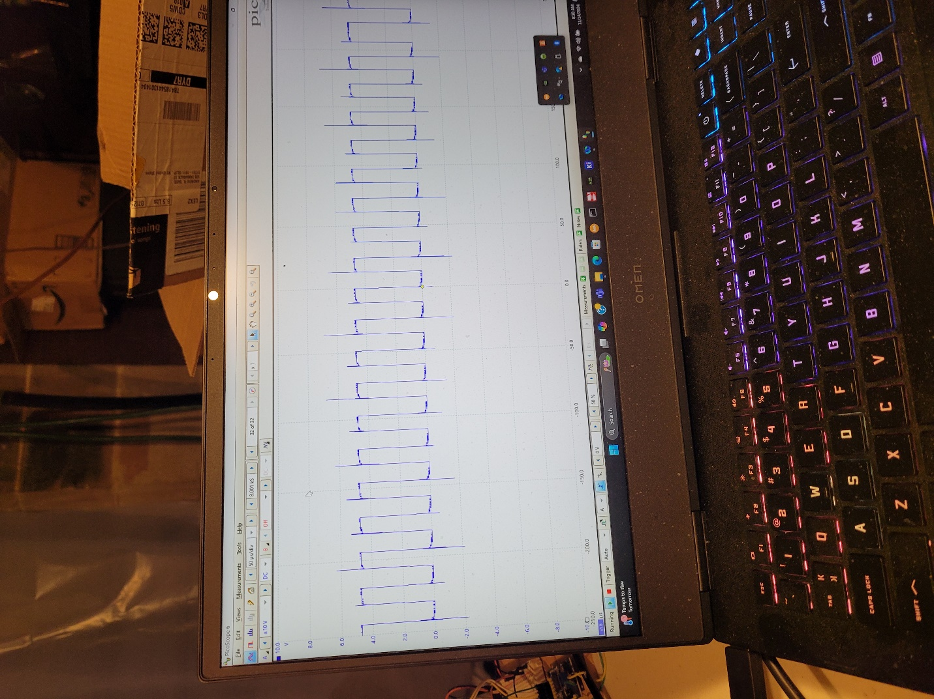

SCOPE 2. PULSE MODULATED 40kHz IR LED SIGNAL

SCOPE 3. PULSE MODULATED 40 kHz IR LED SIGNAL (BLUE)

AND IR SENSOR SIGNAL(RED)

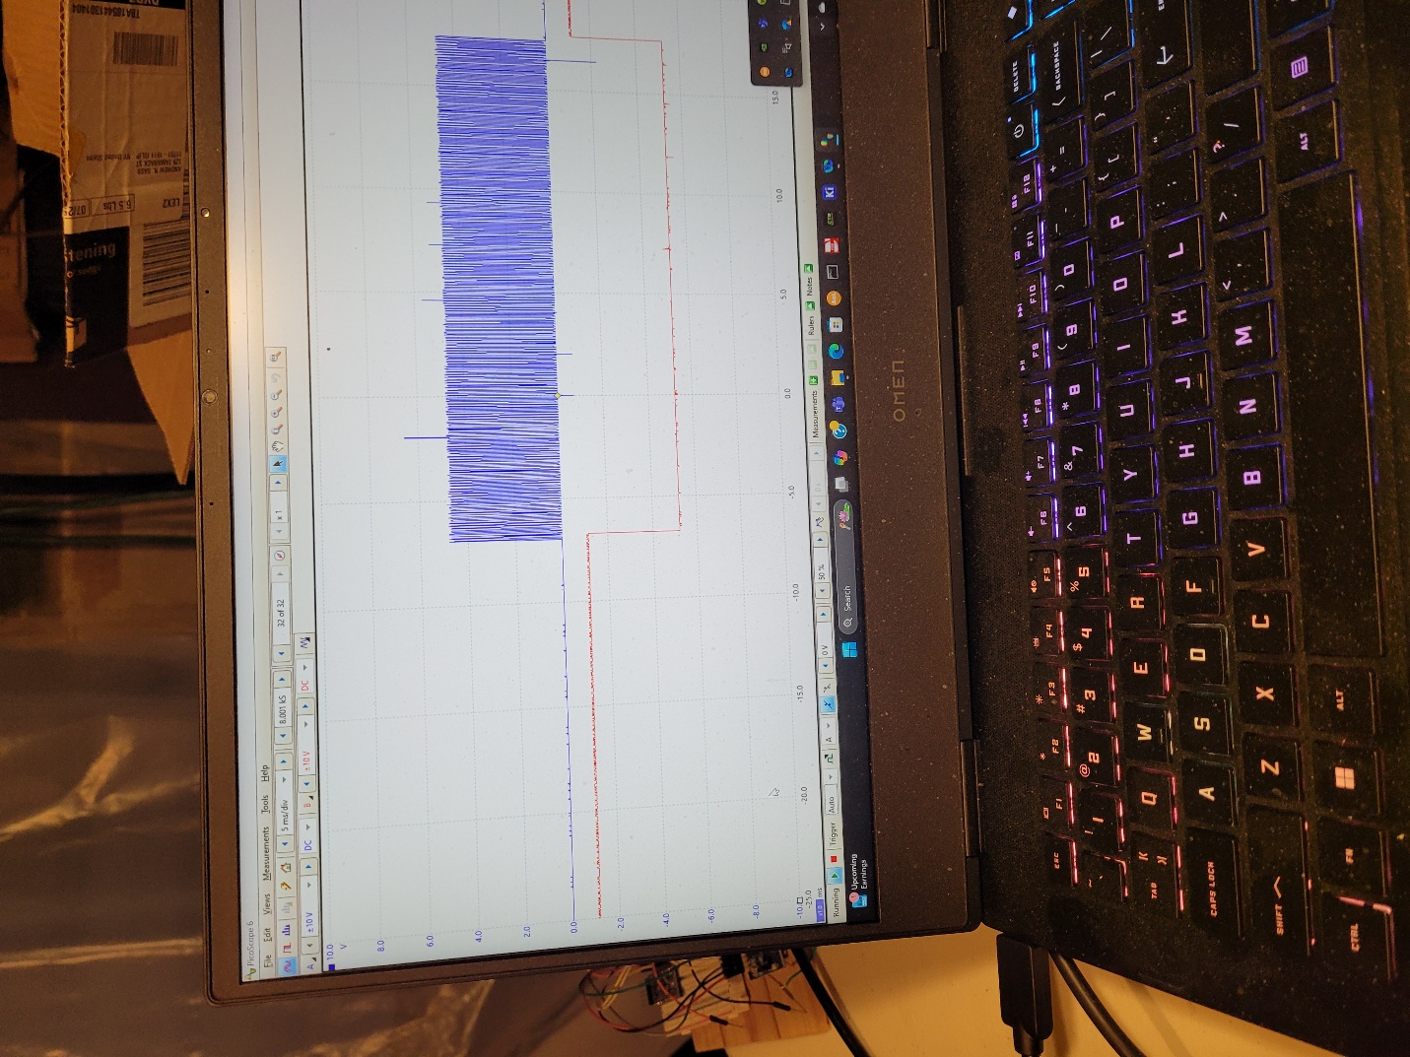

SCOPE 3. PULSE MODULATED 40 kHz IR LED SIGNAL (BLUE)

AND IR SENSOR SIGNAL(RED). 525ms DUTY CYCLE

APPENDIX 2

HOW TO USE THE MOUSE CODE

In order to use the Mouse Code, teams can do some version of the following.

FOR OPTION 1:

void loop(){

while((MOUSE_GOAL_1() == LOW){

*TEAM DESIGNED PROGRAM TO SEARCH FOR GOAL();*

}

while((MOUSE_GOAL_1() == HIGH){

*TEAM DESIGNED PROGRAM TO RETURN TO START;*

}

}

FOR OPTION 2:

void loop(){

while((MOUSE_GOAL_2() == 0){

*TEAM DESIGNED PROGRAM TO SEARCH FOR GOAL();*

}

while((MOUSE_GOAL_2() == 1){

*TEAM DESIGNED PROGRAM TO APPROACH AND TRIGGER BEACON PROXIMITY SENSOR*

*AFTER DETECTING GOAL;*

*Any IR sensors not associated with those in this Tech Bulletin should be turned off.*

}

while((MOUSE_GOAL_2() == 2){

*TEAM DESIGNED PROGRAM TO RETURN TO START;*

}

}